**Hamna Qasim**

**55194**

**Lab 8**

**TASK1:**

<!DOCTYPE html>

<html lang="en">

<head>

    <meta charset="UTF-8">

    <meta name="viewport" content="width=device-width, initial-scale=1.0">

    <title>Document</title>

</head>

<body>

    <div class="Old Class">WingardiumLeviosa</div>

    <script>

        let classn=document.getElementsByClassName("Old Class")[0];

        classn.setAttribute("class", "newclassname");

        let name=classn.getAttribute("class");

        console.log(name);

    </script>

</body>

</html>

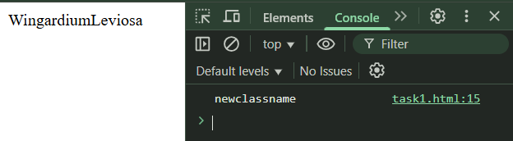

**TASK2:**

<!DOCTYPE html>

<html lang="en">

<head>

    <meta charset="UTF-8">

    <meta name="viewport" content="width=device-width, initial-scale=1.0">

    <title>Document</title>

</head>

<body>

    <p>Login Buttton</p>

</body>

    <script>

        const loginButton = document.createElement("button");

        loginButton.innerText = "Log In";

        loginButton.style.backgroundColor = "purple";

        loginButton.style.color = "white";

        loginButton.id = "logIn";

        console.log(loginButton);

        document.body.prepend(loginButton);

    </script>

</html>

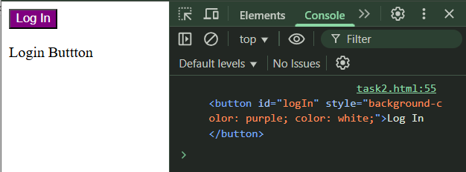

**TASK3:**

<!DOCTYPE html>

<html lang="en">

<head>

    <meta charset="UTF-8">

    <meta name="viewport" content="width=device-width, initial-scale=1.0">

    <title>Document</title>

    <link rel="stylesheet" href="task3.css">

</head>

<style>

    p{

        color: purple;

    }

</style>

<body>

    <p id="paragraph">Morning!!!</p>

    <script>

        let para=document.getElementById("paragraph");

        para.setAttribute("class","style3");

    </script>

</body>

</html>

.style3

{

    color:plum;

    font-size:larger;

}

